Tableau Intro Activity
Department | AI&DS
Course Code / Course Name | DSA0602/ Data Handling and Visualization
Activity | Tableau Intro Activity
Name | Addula Yaswanth
Register Number | 192324179

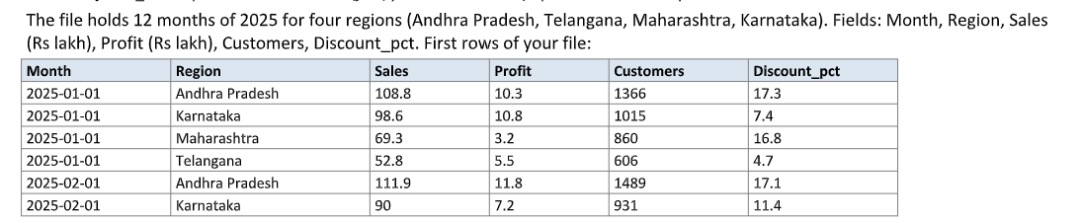
T1. Connect and Check
Tool Used: Tableau Public
Procedure:
- Open Tableau Public and connect to the D_1.csv file using the Text File option.
- Check the data preview and verify the field names and data types.
- Set the Month field to the Date data type.
- Check the number of rows in the dataset.
- Identify the dimensions and measures.
- Calculate the total Sales and total Profit.
Result:
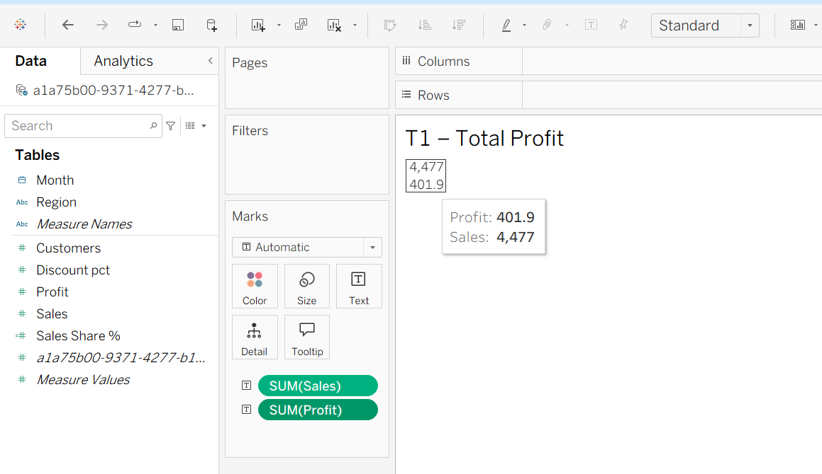
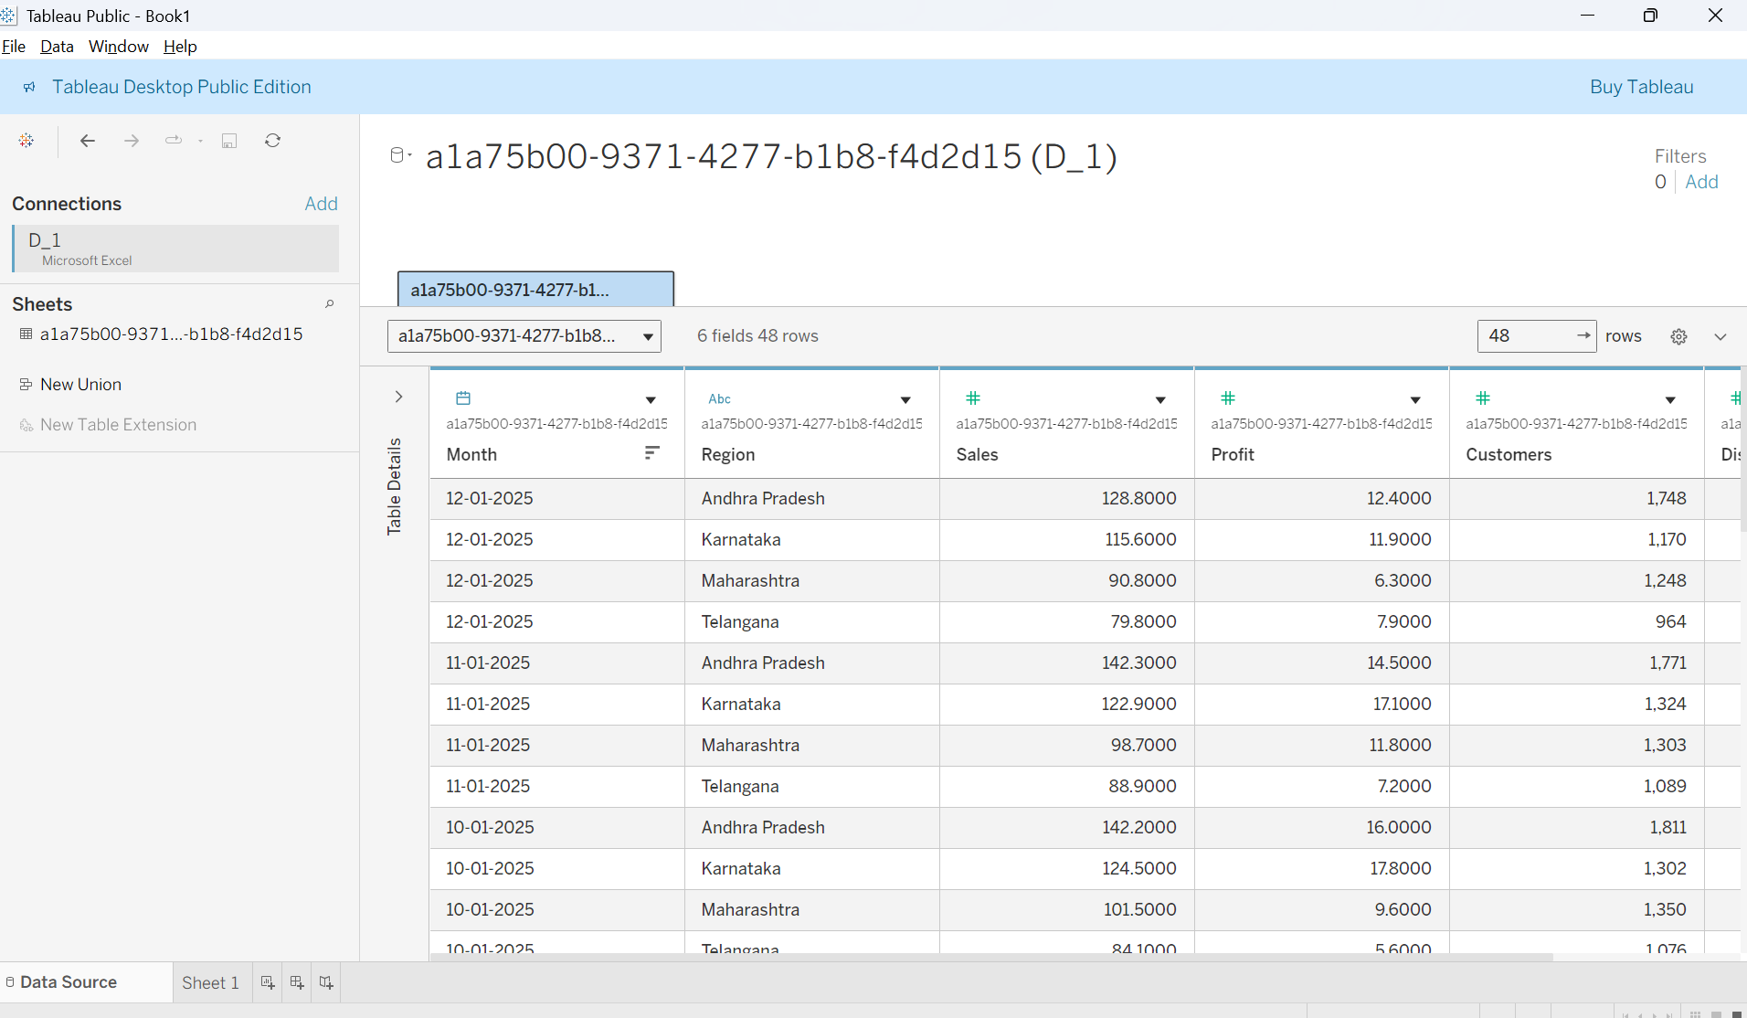

Conclusion: The CSV file was successfully connected to Tableau Public. The fields were classified into dimensions and measures, and the total Sales and total Profit were checked.

T2. Bar Chart – Sales by Region
Aim: To compare total sales across the four regions and identify the highest- and lowest-selling regions.
Procedure:
- Open a new worksheet in Tableau Public.
- Drag Region to Columns and Sales to Rows.
- Select the bar chart from Show Me.
- Sort the bars in descending order of Sales.
- Drag Sales to Label on the Marks card to display sales values on the bars.
- Add the chart title Total Sales by Region.
Result:
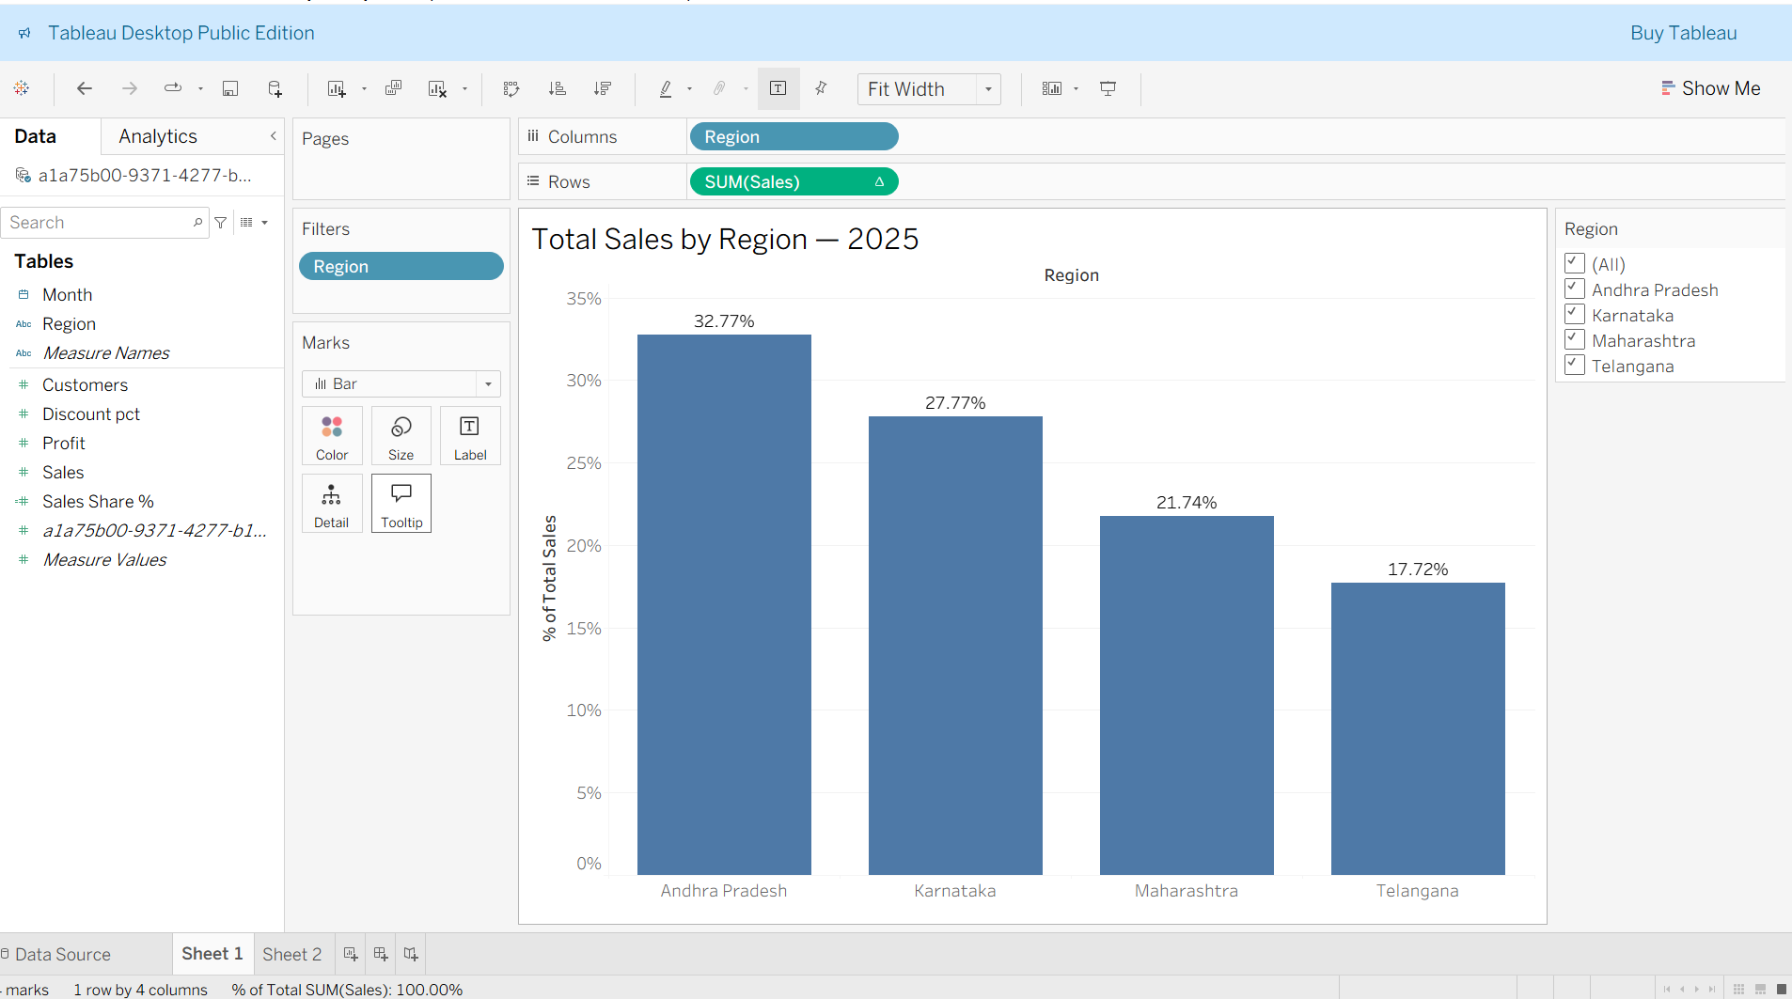

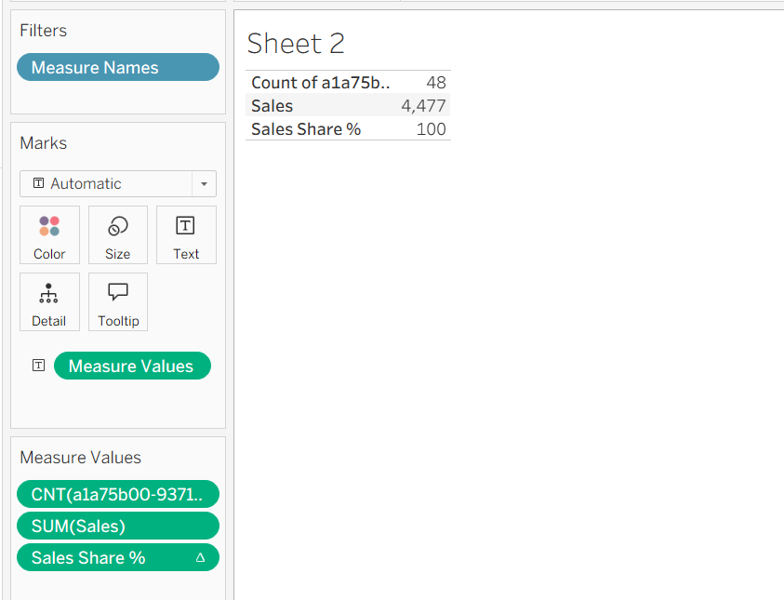
Conclusion: The bar chart compares total sales across the four regions. AP recorded the highest sales, while TG recorded the lowest sales.

T3. Line Chart and Trend
Aim: To analyse monthly sales trends using a line chart, linear trend line, and 3-month moving average.
Procedure:
- Drag Month to Columns and Sales to Rows.
- Select the Line chart.
- Add a Linear Trend Line from the Analytics pane.
- Apply a Moving Average table calculation and configure it to use the current month and previous two months.
- Hover over the chart to identify the peak month and June's moving average.
- Select Describe Trend Model to obtain the trend slope.
Results:
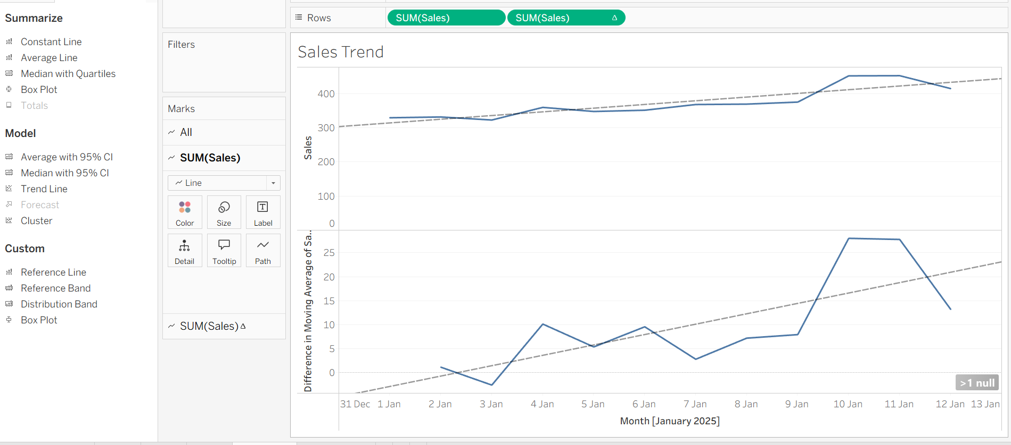
Conclusion: The line chart shows the monthly sales pattern. The trend slope indicates whether sales generally increased or decreased during 2025, while the moving average helps smooth short-term fluctuations.

T4. Scatterplot – Discount vs Profit
Aim: To analyse the relationship between discount percentage and profit.
Procedure:
- Drag Discount_pct to Columns and Profit to Rows.
- Select Circle as the Marks type.
- Turn off Aggregate Measures to display one point per data row.
- Drag Region to Color to distinguish the four regions.
- Add one overall linear trend line using the Analytics pane.
- Select Describe Trend Model to obtain the slope and R-squared values.
Results:
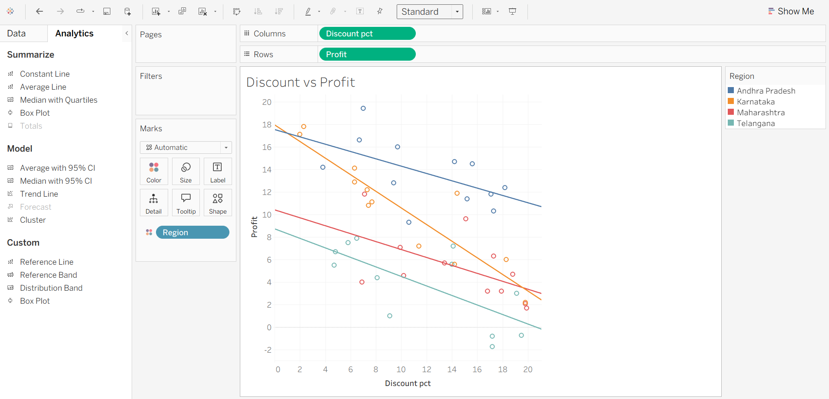
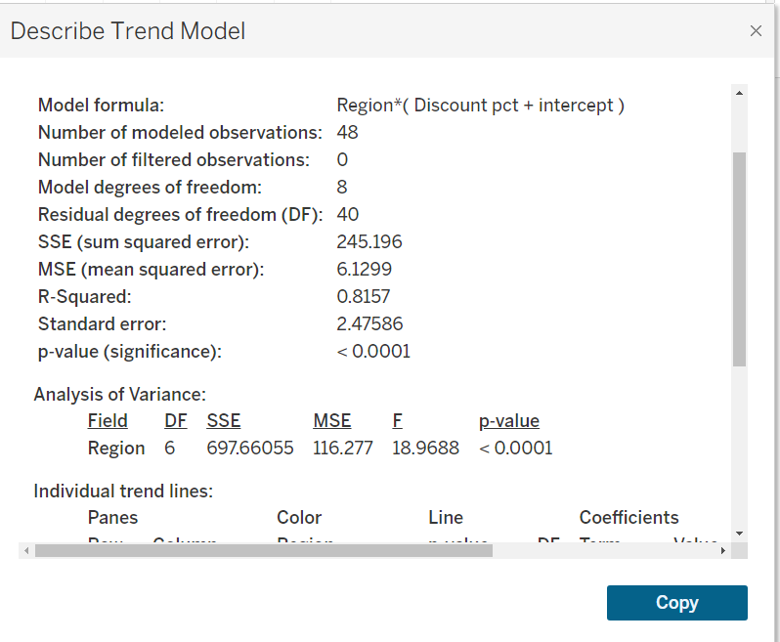
Interpretation: The slope indicates whether profit tends to increase or decrease as the discount percentage increases. The correlation coefficient indicates the direction and strength of the linear relationship between discount and profit.
Conclusion: The scatterplot and trend line help assess whether discounting is associated with changes in profit.

T5. Filled Map – Profit by Region
Aim: To compare total profit across the four regions using a filled map.
Procedure:
- Set Region's geographic role to State/Province.
- Double-click Region to generate the map.
- Drag Profit to Color to display total profit by region.
- Identify the region with the lowest total Profit.
- Calculate its profit margin using Total Profit / Total Sales × 100.
Results:
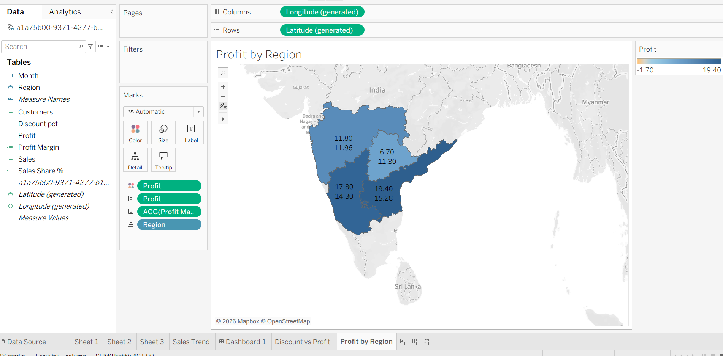
Conclusion: The filled map displays the distribution of profit across the four regions. The region with the lowest total profit was TG, with a profit margin of -1.70%.

T6. Dashboard with a Filter
Aim: To combine the sales bar chart, monthly sales line chart, and profit map into an interactive dashboard.
Procedure:
- Create a new dashboard and add the bar chart, line chart, and filled map.
- Enable Use as Filter on the bar chart.
- Select the region with the second-highest total sales.
- Record its total Sales and total Profit.
- Calculate its profit margin using Total Profit / Total Sales × 100.
- Publish the dashboard to Tableau Public and copy the published link.
Results:
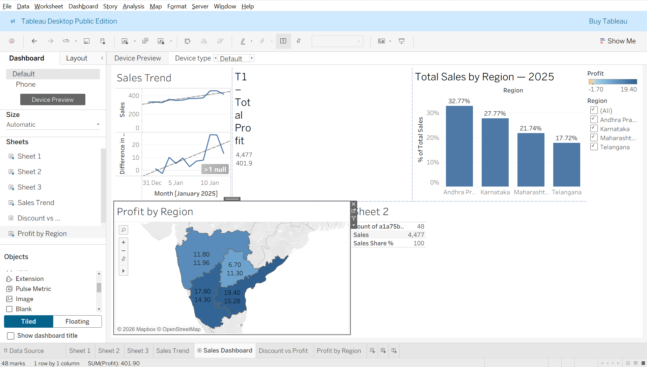
Conclusion: The dashboard combines three visualisations and allows users to explore sales and profit for a selected region interactively.

T7. Compare with R (ggplot2)
Difference 1: Chart creation
In Tableau, a line chart can be created by dragging Month to Columns and Sales to Rows, then selecting Line. In R, a line chart is created by writing code using ggplot2, such as ggplot(data, aes(x = Month, y = Sales)) + geom_line().
Difference 2: Trend line and moving average
In Tableau, a linear trend line can be added through the Analytics pane, and a moving average can be applied using Quick Table Calculation. In R, a trend line can be added using geom_smooth(method = "lm"), while a moving average can be calculated using a function or package such as zoo::rollmean().
Conclusion: Tableau provides a visual, drag-and-drop approach, whereas R uses code to create and customise charts.

